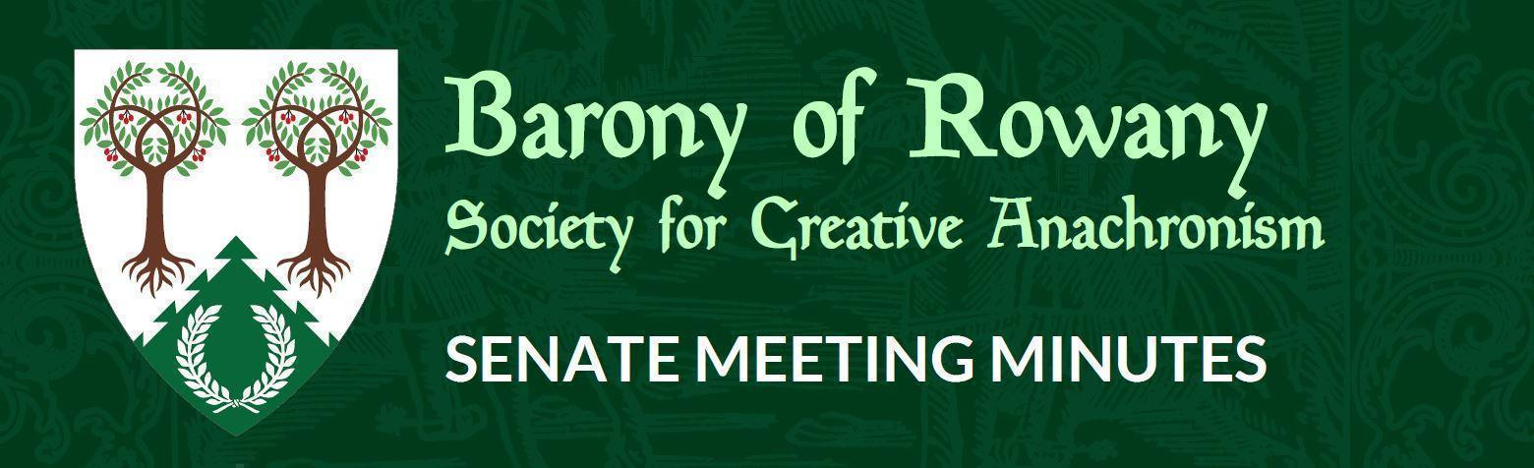

Meeting Date |  | Start time |  | Finish time
28/07/2022 |  | 7.20 pm |  | 7.53 pm
Location | Zoom
Chair | Jean-Christophe le Saussier
Attendees  JC, Elwald, Kinggiyadai, Sigvald, Medb, Katerina, Ran, |  |  | Apologies  Unnr,
Quorum met? (Min 3 officers) Yes

As we meet today in the spirit of furthering knowledge of history, I acknowledge the Traditional Custodians of the lands on which we meet, recognising their continuing connections to land, water and community. I would like to pay respect to Elders past and present.

Agenda Item:

To name Countess Beatrice and Dytryk Lerher as co-Stewards of Festival 2023 and confirm the dates of Festival as being from Stewarding team set up on Saturday April 8th, the event proper running from April 12th to 17th and site close on April 18th. The Stewards are tasked with completing the budget and submitting a full bid in due course.
Seconded: Ran
Ayes: 7
Nays: 0
Abstentions: 0

Concerns raised about possible moving of Village Green. Stewarding team are asked to be mindful of populace concerns about this, and when appropriate to do so, receive commentary from the populace about this.

