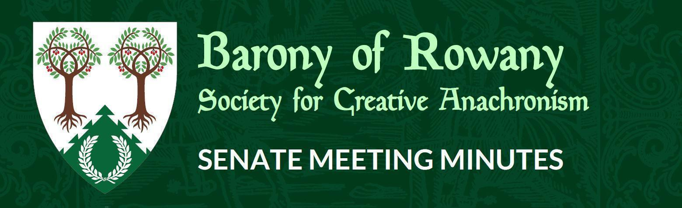

Meeting Date |  | Start time |  | Finish time
20/10/2022 |  | 7. pm |  | pm
Location | Zoom
Chair | Jean-Christophe le Saussier
Attendees  JC, Medb, Stigh, Gomez, Elena |  |  | Apologies  Skiotr
Quorum met? (Min 3 officers) No

I acknowledge the Traditional Custodians of the land on which we meet, and recognise their continuing connection to land, water and community. I pay respect to Elders past, present and.

Attendance

Minutes for previous meeting dated ___/_____/____2022___
Tabled and accepted as being accurate/to be updated as indicated
Motion to accept by
Seconded by:
Ayes:
Nays
Abstentions:

Constable (Katya)
- Nothing to report

Rowany Seneschal (Jean-Christophe le Saussier)
Due to lack of quorum, no meeting for October.

Reeve (Unnr)

Account balances:
Bank balances are:
Rowany $
Festival - $
FAT - $

Baron and Baroness (Cairistiona and Stigh)

Arts and Sciences (Katerina)

Armoured Combat Marshal (Skarp)

Fencing Marshal (Jude)

Captain of Archers - (Skiotr)

Cinquefoil/Herald (Medb)

Hospitaller (Elwald Knudson)

Chirurgeon (Reagan)
List Keeper (Mathilde)

Acquisitor ( Skarp-Heðin Sverðvarpnir)
Webwright (Raegan)

Chronicler (Jude of Lunihawke)

Youth Officer (Eurgain of Whitby)

College of St Ursula Seneschal (Kaitorix)

Stowe on the Wowld (Mathias von Massenbach)

Agenda Items:

General Business

Other business

