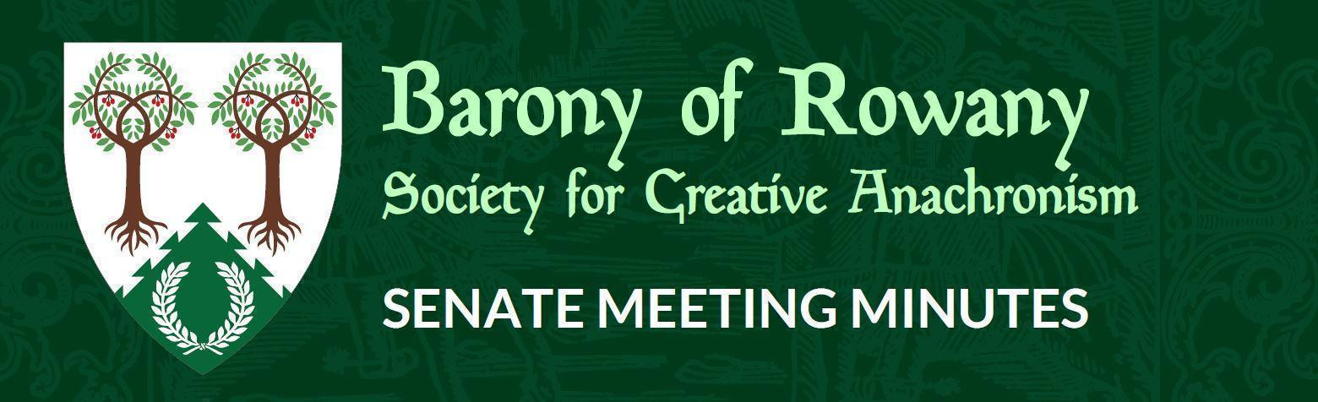

Meeting Date |  | Start time |  | Finish time
21/10/2021 |  | 7.22 pm |  | 7.59pm
Location | Zoom
Chair | Jean-Christophe le Saussier
Attendees  Jean-Christophe, Ran, Mathilde, William, Shinjo, Eurgain, Hideaki, Katerina, Unnr,Kaitorix, Skiotr, Mathias, Arabella, Rosalind (left 7:55pm), Kinggiyadai, Caristiona, Stigh. |  |  | Apologies  Medb
Quorum met? (Min 3 officers) Yes

I acknowledge the Traditional Custodians of the land on which we meet, and recognise their continuing connection to land, water and community. I pay respect to Elders past, present and future.

Attendance

Minutes for previous meeting dated _16__/__09___/____2021___
Tabled and accepted as being accurate/to be updated as indicated
Motion to accept by Jean-Christophe
Seconded by: Katerina

Ayes: 7
Nays: 0
Abstentions: 1

Constable (Katya)

- Nothing to report

Rowany Seneschal (Jean-Christophe le Saussier)

- New officers
- Face to face return
- Festival

Reeve (Unnr)
Report by email:
Account balances:
Rowany - $46,533.06
Festival - $33,207.25
FAT - $8.125.00

- Handover completed and thanks to Skiotr for a very smooth handover!
- All Radburne War refunds have been processed
- Stowe quarterly not yet received, but will be!

Baron and Baroness (Cairistiona and Stigh)
- No missive as of yet due to mundane commitments
- Good to see things opening up in Rowany and around Lochac

Arts and Sciences (Minamoto no Hideaki)
- Thank you and congratulations to Katerina
- Dence Park: they are not yet opened up, but will be opening from 11 November
  - Discussion around possible final Dence Park for 2021 for 14th November or start afresh in 2022 - decision to be made by A&S
  - Carpet - setting up a working group

Armoured Combat Marshal (VACANT)
- Nothing to report

Fencing Marshal (Jude)

Captain of Archers - VACANT
- Candidate has come forward, process will be underway
Cinquefoil/Herald (Medb)
- Nothing on the Heraldic front this month report
Hospitaller (Ran Njalldottir)
- Q&A occurred which was great

Chirurgeon (Reagan)
- Nothing to report

List Keeper (Mathilde)
- Nothing to report
Acquisitor ( Skarp-Heðin Sverðvarpnir)
- Nothing to report

Webwright (Clara)
Nothing to report

Chronicler (Jude of Lunihawke)

Youth Officer (Eurgain of Whitby)

- Nothing new on this front

College of St Ursula Seneschal (Mathilde)

- Things are continuing well
- Informal Christmas party
- Awaiting an invoice for semester 1 - JC to action

Stowe on the Wowld (Mathias von Massenbach)
- Wednesday nights have been progressing online, but are sparsely attended so far - some regulars

General Business
- Crown Events Deputy seeking expressions of interest
- Lochac Seneschal survey
- Yule is looking good to continue given the general circumstances
  - Taking money after bookings
  - Won’t have Crown but have visiting Excellencies
- Archery at Yule - JC to get Yule Stewarding Team, Gregor and Skiotr in contact.

Other business

