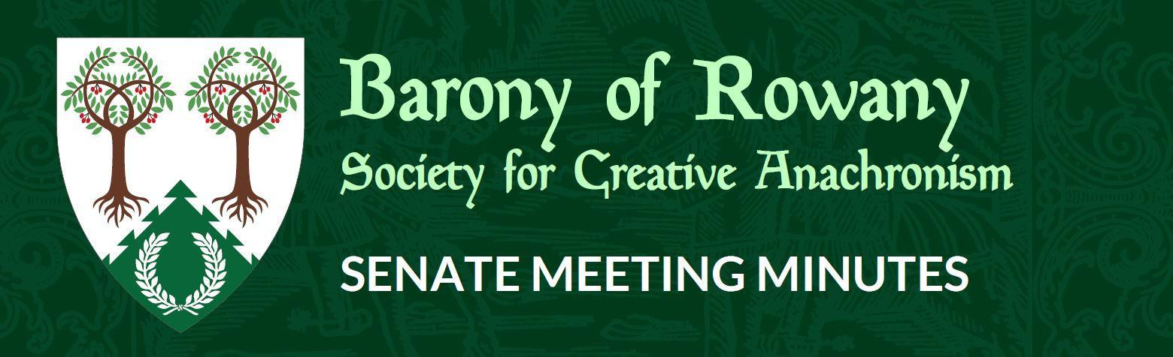

Meeting Date |  | Start time |  | Finish time
16/11/20 |  | 7.16 |  | 8:05
Location | Discord
Chair | Gomez de Crecy
Attendees  Attendees  Gomez, Katya, Mathias von Massenbach, Mathilde, Shinjo Takame, Reagan, Jean-Christophe, Ran Njalldottir, Kinggyadai, Stigh, Caristiona, Arabella, Hideaki. |  |  | Apologies
 |  |  | Discord
Quorum met? (Min 3 officers) Yes

I acknowledge the Traditional Custodians of the land on which we meet, and recognise their continuing connection to land, water and community. I pay respect to Elders past, present and emerging.

Attendance

Minutes for previous meeting dated __19___/__10___/____2020___
Tabled and accepted as being accurate/to be updated as indicated
Motion to accept by Gomez
Seconded by: JC
Carried: Yes

Constable (Katya) Reported
N/A

Rowany Seneschal (Gomez de Crecy)
Congratulations to the receivers of the Crown Cypher. Jean Christophe, Hideaki, Ran, Shinjo, Yolande. Medb ingen ind Iasachta, Louise Braos .Very well deserved.

Yule is coming. Ran has the Saturday under control.
Jude is Sunday in total or just fencing? Sunday needs list fields, sign in doc, advertising.

Motion: That the Treasurer of SCA Ltd reactivates the Festival Square account for taking payments.
Second: JC
Carried.

Next Seneschal might think about Zoom over Discord. No saved text but some people can't get Discord to work well.

Applications for Baronial Seneschal have closed. One applicant but can't call for commentary until KS has given her assent. Then commentary. Plan is to then have a debrief and hand over at Yule.
I'll take them completely through the November Seneschals report as the next isn't until Feb 2021.

This is my last meeting as Seneschal. I've been coming to these for years and that's not likely to change. Why waste having an opinion. So I'll still be here, just a bit quieter.

Reeve (Schorryn) Reported
Rowany Account: $45,335.97
Festival Account: $41,751.25

Everything is reconciled

Baron and Baroness (Cairistiona and Stigh)

Arts and Sciences (Minamoto no Hideaki) Reported

Heavy Marshal (Leif Eddison) Nothing to report
Warrant of Heavy Marshall is extended to 30/6/2021. Approved by Heavy Marshal and EM.
Heavy twice at Dence Park.

Rapier Marshal (Chris Lloyd-Jones) Nothing to report
Fencing twice at Dence Park. Much fun.

Captain of Archers (William de la Montaigne Coupe) Reported
N/A

Cinquefoil/Herald (Rosalind Beaufort)
One new name and device submitted

Hospitaller (Ran Njalldottir) Reported
Yule prep is underway.

Chirurgeon (Reagan) Reported
N/A

List Keeper (Mathilde) Reported Nothing to report.
N/A

Acquisitor ( Skarp-Heðin Sverðvarpnir)
N/A

Webwright (Clara via Gomez)
Demo of new system.

Chronicler (Jude of Lunihawke)

N/A

College of St Ursula Seneschal (Arthur) (Report made by Mathilde)

Stowe on the Wowld
Stowe Seneschal - How is handover going? Any word on combined gatherings at Wentworthville? Still a work in progress.

General Business

Festival Report (Kinggyadai)
Drop dead date for go/no go is the end of January. We are about to open ticket sales.

Other business
Email motions have been proposed, seconded and voted on between meetings.

Motion:
Here is my proposal for 12 Dec Online Yule Feast
Date: 12 December 2020
Time: Estimated 6:30 pm to 9pm (actual times TBD by availability of the Baron and Baroness and also Boars head planning/other possible activities).
Setting: Zoom
Participants: Max 100
Registration process: Google form (to capture emails and then send out the Zoom link and also capture any relevant information about newbies and barony locations).
Description:Gather round your hearths and prepare your favourite dishes for this festive time of year. Come and enjoy connection with those far and wide. It’s Yule and me together! Virtually.

Approved.

