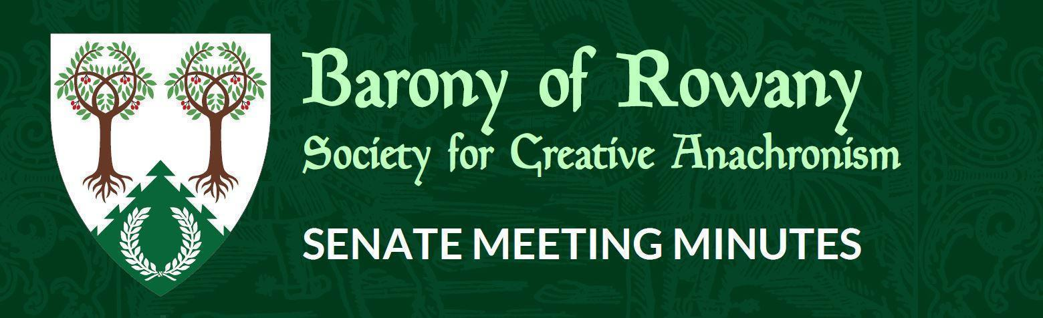

Meeting Date |  | Start time |  | Finish time
19/05/2022 |  | 7.20 pm |  | 7.43 pm
Location | Zoom
Chair | Jean-Christophe le Saussier
Attendees  JC, Medb, Kinggiyadai, Elwald, Unnr, Rosalind, Ran, Arabella, Mathias, Skiotr(7.25pm) |  |  | Apologies
Quorum met? (Min 3 officers) Yes

I acknowledge the Traditional Custodians of the land on which we meet, and recognise their continuing connection to land, water and community. I pay respect to Elders past, present and future.

Attendance

Minutes for previous meeting dated _28__/__04___/____2022___
Tabled and accepted as being accurate/to be updated as indicated
Motion to accept by Jean-Christophe
Seconded by: Unnr
Ayes: 5
Nays: 0
Abstentions: 1

Constable (Katya)
- Nothing to report

Rowany Seneschal (Jean-Christophe le Saussier)

- Quarterly report submitted, thanks to officers who had their reports in on time
- Blacktown Medieval Faire postponed to September
- Seneschal’s Meeting on Sunday
- Mordenvale Donation occurred, thanks are passed along. St Floz has donated $1001. Good to see us leading and inspiring the Kingdom

Reeve (Unnr)

Account balances:
Rowany $45,702.37
Festival $35,915.23
FAT $14,019.83

- Festival mostly sorted

Baron and Baroness (Cairistiona and Stigh)

Arts and Sciences (Katerina)

Armoured Combat Marshal (VACANT)
- No stated incidents this month. Awaiting Festival Marshal report
- Commentary period ongoing for Skarp-Hethin to become AC Marshal

Fencing Marshal (Jude)
- No major issues

Captain of Archers - (Skiotr)
- 2 viable options: Canada Bay Council/Greenlees.
- Motion to approve $35 for council application + $100 bond if successful
Second:
Ayes:
Nays:
Abstentions:
Due to technical issues, this motion was unable to be moved successfully. Held over to June.

Cinquefoil/Herald (Medb)
- Herald tabards
- Motion: That we pay for costs to repair the Rowany Herald Tabard (with the removable sleeves)
Second: Ran
Ayes: 9
Nays: 0
Abstains:

Hospitaller (Elwald Knudson)
- Newly in office
Chirurgeon (Reagan)
- Noone died for realsies

List Keeper (Mathilde)
- Nothing to report
Acquisitor ( Skarp-Heðin Sverðvarpnir)
- Nothing to report

Webwright (Raegan)

Chronicler (Jude of Lunihawke)
- Nothing

Youth Officer (Eurgain of Whitby)

College of St Ursula Seneschal (Kaitorix)

- Quarterly report received

Stowe on the Wowld (Mathias von Massenbach)

- Tavernalia in a few weeks. Spots still available! Small tournament in the afternoon, tavern food, light hearted fun
- Winterfest the first weekend of July. Any help will be appreciated!
- Still looking for a new hall. Any assistance in finding a new hall is also appreciated.

General Business

Other business

