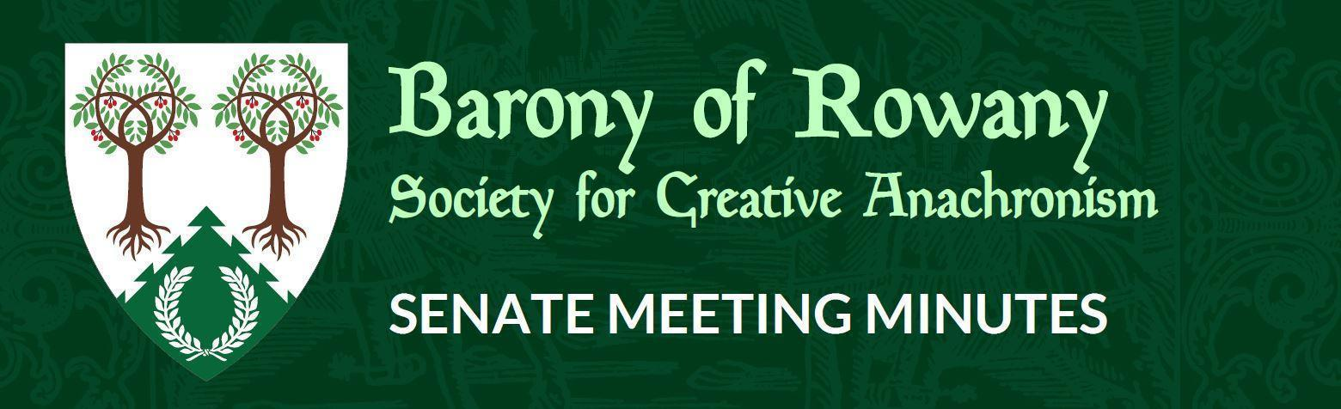

Meeting Date |  | Start time |  | Finish time
25/01/2021 |  | 7.15pm |  | 8.30pm
Location | Discord
Chair | Jean-Christophe le Saussier
Attendees  Jean-Christophe, Gomez, William, Katrijn, Katya, Kinggiyadai, Juliana (7.45), Eurgain, Raegan, Ran, Shinjo, Stigh, Caristiona, Medb, Rosalind (at 8.29) |  |  | Apologies  Mathilde, Skiotr, Mathias.
 |  |  | Discord
Quorum met? (Min 3 officers) Yes

I acknowledge the Traditional Custodians of the land on which we meet, and recognise their continuing connection to land, water and community. I pay respect to Elders past, present and emerging.

Attendance

Minutes for previous meeting dated __21___/__12___/____2020___
Tabled and accepted as being accurate/to be updated as indicated
Motion to accept by Jean-Christophe
Seconded by: Gomez
Ayes: 6
Nays:
Abstentions: 5

Constable (Katya)
Nothing to report

Rowany Seneschal (Jean-Christophe le Saussier)
- Motion for refunds for 2021
Background: In 2020, an interpretation of the Financial Policy by Kingdom Exchequer was that refunds are considered an expenditure by the Barony, and therefore require approval by the group at a council meeting. In order to allow the Reeve and event stewards to process refunds in a timely manner, I propose a motion giving the Stewards of Events dispensation to refund event fees for all events run by the Barony of Rowany, including Rowany Festival, for the calendar year of 2021.
- Seconded: Gomez
  - Ayes:12
  - Nays:0
  - Abstentions: 0
- Kingdom Law requires ongoing financial expenditure to be approved each year.
Motion: Approval for payment of regularly used venues (including but not limited to: Herb Greedy Hall, St Peters Public School, and Dence Park) and for ongoing payment of storage unit.
Seconded: Caristiona
Ayes:12
Nays: 0
Abstentions:0
- Reminder that funds may be approved by a Council of the Purse outside of monthly meetings. This CoP will be comprised of the officers of the Barony and it will be conducted by email and reported at the next Senate meeting.

- New Kingdom Deputy Seneschal for COVID will be announced shortly. Will help local Seneschals with managing COVID requirements for events moving forward.
  - Whilst we do not require a COVID Marshal under NSW law, we may want event stewards to have a COVID Marshal, as a deputy steward, for the purposes of ensuring restrictions/requirements are adhered to.
- Friendly reminder that officer Reports Due 15 Feb
- Fighter Auction Tournament now has a separate account! Account signatories:
  - Motion: That Christopher Colefax, known in the Society as Jean-Christophe le Saussier be added as a signatory to the Rowany, Rowany Festival and Rowany Fighter Auction Tournament bank accounts AND that Scott Rymill, known in the Society as Skiotr be added as a signatory to the Rowany Fighter Auction Tournament bank account
Seconded: Kinggiyadai
Ayes: 12
Seconded by: Kinggiyadai
Ayes: 12
Nays: 0
Abstentions: 0
  - Motion:
Nays: 0
Abstentions: )
  - That Celine Perczynski, known in the Society as Leifa of Dismal Fogs, be removed as a signatory from the Rowany and Rowany Festival bank accounts.
Seconded: Caristiona
Ayes:12
Nays:0
Abstentions: 0
- Meetings on Zoom
  - After raising at last meeting and talking to other people, having a Zoom license for meetings (and potential online events) looks like a good plan. Most appropriate license will cost $209/yr.
  - Host up to 100 participants
  - Group meetings for up to 30 hours
  - Social Media Streaming
  - 1 GB Cloud Recording (per license)
- Motion: That the Barony purchase a Zoom license, at the cost of $209/yr and associated with the Rowany Seneschal email account, to use for online meetings and events.
Seconded: Stigh
Ayes: 12
Nays: 0
Abstentions: 0
- Noted that Scouts Australia have cancelled Jamboree for 2022
- Motion: It is with sadness that Rowany Senate ratifies the decision of the Festival Executive Committee to not proceed with Rowany Festival 2021.
Seconded: Kinggiyadai
Ayes: 12
Nays: 0
Abstentions: 0
- Kinggiydai will post the cancellation announcements
- Kinggiyadai would like to thank the Stewarding Team for their efforts this year.
- Thanks from Rowany Seneschal to Kinggiyadai for stepping up as Rowany Festival Steward 2020 and 2021, even though neither event was able to be run. However, 3rd time will not be lucky and an advertisement for a new Steward for 2022 will be held.

Reeve (Skiotr)
Email report Jan 20:
Quarterly and Domesday Reports completed on time and shared with Seneschal.
All transactions to 31/12 reconciled.
Some Festival related transactions remain to be reconciled as at Jan 8th.

Rowany Account: $46325.97
Festival Account: $57547.85
(As at 31/12/2020)

Baron and Baroness (Cairistiona and Stigh)
Report posted last week
Welcome to the new Crown
Live stream was very exciting to allow us to watch from afar!
Good to see Theuderic and Engelin become Duke and Duchess after their very long reign

Arts and Sciences (Minamoto no Hideaki)
Nothing to report

Heavy Marshal (Leif Eddison)
N/A
Rapier Marshal (Chris Lloyd-Jones)
N/A
Captain of Archers (William de la Montaigne Coupe)

No archery at the moment.
Beginning process of looking for a replacement due to medical issues.

Cinquefoil/Herald (Rosalind Beaufort)
Deputy advertisement to be going out shortly
Warrant ends in April, so looking for successor in near future.

Hospitaller (Ran Njalldottir)
Have been coordinating with A&S Officer about online content.
Things have been pretty quiet

Chirurgeon (Reagan)
N/A

List Keeper (Mathilde)
Nothing to report

Acquisitor ( Skarp-Heðin Sverðvarpnir)
N/A

Webwright (Clara via Gomez)

N/A

Chronicler (Jude of Lunihawke)
N/A

Youth Officer (Eurgain of Whitby)
Enquiry on proposal from a previous meeting - JC to follow up

College of St Ursula Seneschal (Mathilde)
Quarterly report completed!
We might be having in person events at uni soon! I’m currently waiting to hear back on whether an in person o week and demo will be happening and will keep the barony up to date on that because we’d like some volunteers for a demo if possible, but more to come on that. Was wondering whether I’d have to do the SCA covid paperwork for weekly A&S and follow SCA covid guidelines as well as uni ones? We have to take attendance for the uni so if needs be I can copy constab in on that.

Stowe on the Wowld (Mathias von Massenbach)

Quarterly report sent.
Meeting held on Wednesday 13/1/21.
Looking to restart activities in near future.

General Business

- Radburne War Proposal
  - War event on weekend 27th August. Part catered.
  - Go/No Go: Approx early August, but can be made as late as 1 week before
  - Motion: That an in principle approval for Radburne War 27-29th August 2021 is granted, pending government restrictions and the COVID situation at the beginning of August
Seconded: Caristiona
Ayes: 12
Nays: 0
Abstentions: 0
- Resumption of face to face activities
  - Discussion around venues
  - Government restrictions likely reviewed on 28/1
  - Holding decision to that point

Other business
Email motions:

