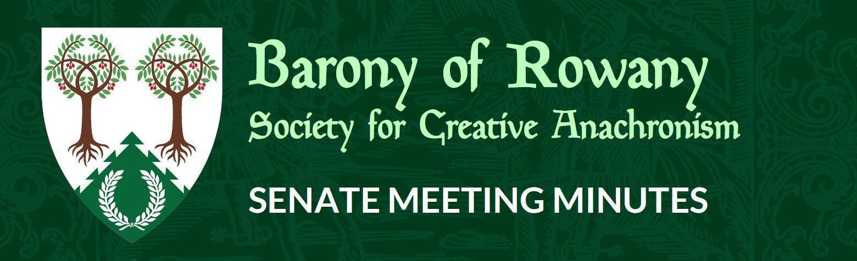

Meeting Date |  | Start time |  | Finish time
N/A
Location | Zoom
Chair | Jean-Christophe le Saussier
Attendees  No meeting for December 2021 |  |  | Apologies
Quorum met? (Min 3 officers)

I acknowledge the Traditional Custodians of the land on which we meet, and recognise their continuing connection to land, water and community. I pay respect to Elders past, present and future.

Attendance

Constable (Katya)

Rowany Seneschal (Jean-Christophe le Saussier)

Reeve (Unnr)

Baron and Baroness (Cairistiona and Stigh)
Arts and Sciences (Minamoto no Hideaki)

Armoured Combat Marshal (VACANT)

Fencing Marshal (Jude)

Captain of Archers - VACANT

Cinquefoil/Herald (Medb)

Hospitaller (Ran Njalldottir)

Chirurgeon (Reagan)

List Keeper (Mathilde)

Acquisitor ( Skarp-Heðin Sverðvarpnir)

Webwright (Clara)

Chronicler (Jude of Lunihawke)

Youth Officer (Eurgain of Whitby)

College of St Ursula Seneschal (Mathilde)

Stowe on the Wowld (Mathias von Massenbach)

General Business

Other business

