

Meeting Date |  | Start time |  | Finish time
15/08/2024 |  | 7:03 |  | 7:42
Location | Zoom
Chair | Elena de Moravia
Attendees: Fabia, Eurgain, Hrafn, Norbert, Amy, Katerina, Ibn Jelal, Katya |  |  | Apologies: Ameline, Juliana
Medb, Raegan, Rosalind
Quorum met? (Min 3 officers) |  |  | Yes
I acknowledge the Traditional Custodians of the land on which we meet, and recognise their continuing connection to land, water and community. I pay respect to Elders past and present.
Minutes for previous meeting dated 18 /07/2024
Tabled and accepted as being accurate/to be updated as indicated.
Motion to accept by Elena.
Seconded by: Raegan
Ayes:9
Nays:
Abstentions: 2

Constable (Katya)
- Nothing to report, everything is working fine and smoothly
Rowany Seneschal (Elena)
- Nothing major to report,
- Happy to have a new Chronicler in Katerina! Thanks as well to Katya for stepping in as deputy seneschal. Most of the officer roles are now filled, apart from Lists and Chirurgeon, which is very exciting.
Reeve (Ameline - in absentia)
Account balances:
Rowany $18,627.15
Festival $57,150.74
FAT $24,857.37

- Updates to Rowany Financial policy discussed last month: no further comments were received.
  - 20240718-policy-Rowany Finance Policy - Draft revisions highlighted.pdf
    - Medb was concerned about the 4.2 revision - Hrafn clarified that this was to break down budgets in finer detail.
    - Medb also disagreed with 5.3 revision, with concerns that things may crash, or people who are not regulars or who don’t have a debit card may have difficulties.
      - Katya provided insight that the exclusive use of square at weekly Fighter Practice has not been an issue. Any issues with square were solved by bank transfers.
      - Elena highlighted that going cashless makes it much easier on those who are managing sign-ins, and pointed out that almost everyone can do a bank transfer.
      - Raegan also highlighted the provision of “where possible”, so work arounds can still be possible or managed privately
      - Medb had additional concerns that not every event in sydney would be appropriate to use square
      - Norbert pointed out that this provision was simply “no cash”, not just square
      - Medb was also concerned that the ease of use of the square at weekly Fighter Practice was due to the fact that most people were prepared, or covered by the quarterly payment
      - Katya noted that she had received very positive feedback regarding the transition to cashless being easier for people who don’t carry cash
      - Norbert also emphasised that the vast majority of people have no troubles with square, and the benefits for reporting etc are substantial and possibly outweigh hypothesising about the vanishingly small minority of people who may need to do cash only

Motion to approve suggested amendments by Elena
Seconded by: Elwald
Ayes: 8
Nayes: 1
Abstentions: 3
Please email concerns to Ameline

- Has a Deputy Reeve - Raegan! Very exciting. We should give her access to the relevant accounts:
Motion to approve Justine Gleeson to have access to Xero and Westpac accounts, pending confidentiality agreements, by Elena
Seconded by: Katya
Ayes: 10
Nayes:
Abstentions: 2
Baron and Baroness (Juliana and Tariq ibn Jelal)
- Juliana sends apologies
- It has been a quiet month, but both are looking forward to Gilded Symposium
- If anyone has recommendations for awards later in the year, please send them through
Arts and Sciences (Kaitorix)
- Not too much to report - Dence Park has been running, Summer Hill will be starting soon.
- The Spring Crown A&S competition has been advertised, happy to assist with early entires but so far no takers
- St Ursula is starting semester again so organising classes
Armoured Combat Marshal (Stigh)
- nothing to report
Fencing Marshal (Amy)
- business as usual, nothing to report
Captain of Archers (Norbert)
- Hasn’t progressed with getting new targets. Hopefully a quote will be ready by next Senate
Cinquefoil/Herald (Hrafn)
- Nothing of major note
- Has completed handover with Medb
- One or two consults are in progress, but will need to reach out to colleagues.
Hospitaller (Elwald)
- We had some newcomers attend Masked Ball - it was good to see newcomers at a garbed event!
- Will be poking his head in at Petersham Medieval Day to see if we should do a demo next year
- A few newcomers also came to Dence Park
Chirurgeon (Vacant)
- nothing to report
List Keeper (Vacant)
- nothing to report
Acquisitor (Fabia)
- Overhaul project underway - hoping to complete stage 1 soon.
- Greatest challenge has been actually working in the storage cage, and finding appropriate boxes. Have found best option to be they grey heavy duty storage boxes from Kmart, as they are the most ergonomic and the best use of space both within the storage room and in cars etc
  - Would like to have approved reimbursement of purchased boxes, and approval for new boxes.
- Encourages anyone who would like assist in stages 2, 3 and 4 (where we figure out what we want and need as well as actually getting stuff) to let her know their interest via this form: https://forms.gle/yCHBkCuyYCrnRq9z7
Once enough people have volunteered, will organise discussions most likely over Zoom.
- Would like to organise a working bee in the nearish future to help move some things around in there as she cannot reach everything and some things are too heavy by herself.
Motion to approve up to $150 for more storage boxes by Elena
Seconded by: Ibn Jelal
Ayes: 11
Nays: 0
Abstain: 1

Webicler (Katerina)
- handover hasn’t happened but will soon
Youth Officer (Eurgain)
- nothing to report
College of St Ursula Seneschal (Astreta)
- nothing to report
Stowe on the Wowld Seneschal (Elvira)
- nothing to report
Agenda Items:
- Approval of Festival 2025 ticket prices, as per part of the bid from Rowland and Gilchrist

At a glance:
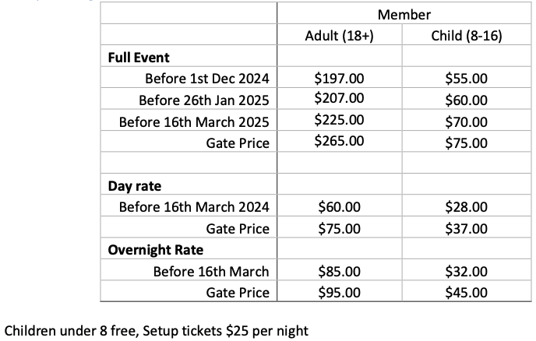
- Note that based on feedback, this does not include a pewter event token (although there will be another token). Pewter tokens for those wanting them will be an additional $3-5, depending on quotes.

- Rosalind and Medb were not fans of the removal pewter token. Elena noted this was based on feedback
- Eurgain asked who they surveyed, to which Elwald answered that there was a public link.
- Raegan noted that this was at the stewards discretion and can always be re-included if feedback is negative.

Motion to approve Rowland and Gilchrist’s proposed Festival 2025 event ticket pricing put forward by Elena
Seconded by: Katerina
Ayes: 11
Nays: 0
Abstain: 1

General Business:
- Elwald have we heard anything about stowe sunday, not on the calendar need to advertise
Other Business:

