Baroness Kolfinna loves fighting in war but is a scaredy-cat and needs people to hide behind. Mordenvale doesn’t currently have tabards and war shields because all our tabards and war shields got burnt up.
If we had tabards and war shields, not only would it be great for the renown of the barony, as our heraldic display would be amazing, but Baroness Kolfinna would stop being shot so much which she is big keen on.

Fighter Auction Tourney funds request
Name: Baroness Kolfinna Burlufótr (Roishin Hanwright)
Location: Mordenvale
What is the bid for? Our bid is to purchase materials for making 12 aluminum war shields.
Mordenvale is in the process of replacing war equipment from our fire. We have approved the purchase of materials for tabards but are looking to upgrade our previous plywood shields for aluminum shields. These come at a higher cost and so we are seeking assistance with this purchase by way of FAT funding.
12 shields are requested as this would accommodate numbers for the current war unit/heraldic melee team, with 2 different sizes to improve inclusivity and accessibility for different body sizes.
The below picture shows an example of both a small and large shield in the colours of a local household.
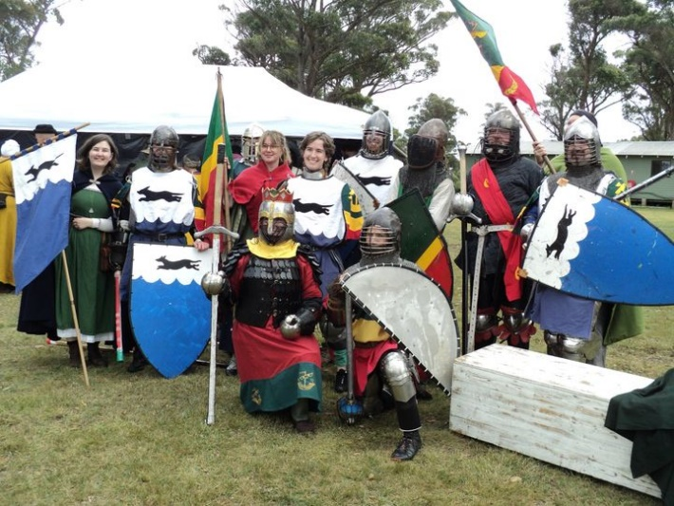
Figure 1: Imagine this, but with more red green and gold.

Who will directly benefit from this bid?
The direct beneficiary is the fighting community of Mordenvale.
By replacing our shields, we can improve our appearance and effectiveness on the war field.
Typically, war shields are larger than those used on the tourney fields. By having a baronial supply, Individual fighters will not need to have their own also this will reduce costs and equipment needs for the individuals in our fighting community.
By replacing them with aluminum, which is much lighter than the alternative plywood, we improve the usability of the shields and make them more appealing to use. When considering using the shields across a war weekend, lighter shields are better for a fighter’s endurance meaning they can stay on the field for longer and in the longer term prevents overuse injuries of the shoulder which can be associated with heavier shields. Further, lighter aluminum shields are more inclusive as they improve usability and accessibility for smaller fighters who may otherwise be unable to use plywood shields of a size appropriate for war.
This bid would also benefit the wider barony as War shields, in combination with our already approved tabards, would present a fantastic heraldic display which would improve the appearance, cohesion and renown of our barony and unit. This concept could be stretched to include the wider kingdom as big pretty units look good in media and promotional materials.
In the short term, we would be able to use the construction of the shields to engage the wider barony in a group project to make the shields which could include those interested in painting, metal and leather work to name a few.
Our group regularly travels for war events with the current B and B attending between 4 and 8 war events per year. We feel the shields would see regular use.
What is the total cost ? Total cost is $1705 for 12 shields (6 Large and 6 small).
The table below includes a breakdown of this cost.
Aluminum |  | Quantity | Totals
Aluminum price for large shield | $140 | 6 pieces | $840
Aluminum for small shield | $70 | 6 pieces | $420
Edging | $25 | 9m | $225
Fittings | $10 | 12 sets | $120
Paint |  |  | $100
 |  | Total | 1705

This equates to approximately $107.09 per small shield and $177.09 per large shield.

Did you obtain quotes? If so, please provide details.
Costings are based on the manufacturing price of similar shields that had been made for a local Household, Hound over Water. This includes Aluminum at the price that Duke Rowland can obtain it, with cost for paint fittings and edging at Bunnings prices.
What amount are you requesting from the Fighter Auction Tourney funds?
We are requesting the full cost from the FAT fund. This comes to a total of $1705.
Mordenvale is still in the process of replacing equipment from fire which included the loss of the vast majority of our martial equipment. We have recently approved and are in the process of making new tabards but shields on top of this represent a large outlay which funding from FAT would help alleviate.
Is there any other information you would like to provide?
The war unit is a central part of the culture within Mordenvale. Our fighting community and war group has been growing over the last few years, with our group traveling regularly to many events within the wider kingdom. Helping us to invest in our community will support his growth and may encourage further vigor in the wider community.

