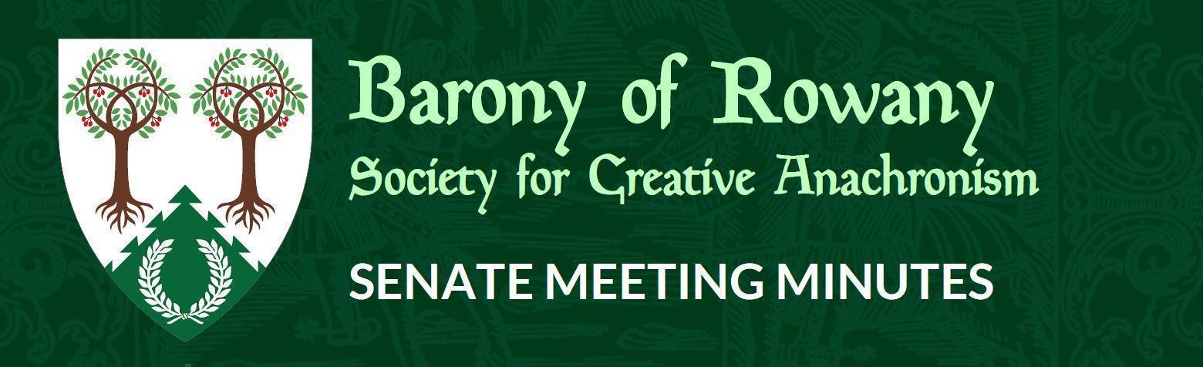

Meeting Date |  | Start time |  | Finish time
20/7/23 |  | 7:19pm |  | 8:18pm
Location | Zoom
Chair | Elena de Moravia
Attendees:  Unnr  Ameline  Ran  Katerina  Elwald  Skiotr  Kinggiyadai  Juliana and iJ |  |  | Apologies:
Eurgain
Medb
Quorum met? (Min 3 officers) Yes

I acknowledge the Traditional Custodians of the land on which we meet, and recognise their continuing connection to land, water and community. I pay respect to Elders past and present.

Attendance

Minutes for previous meeting dated 15/06/2023
Tabled and accepted as being accurate/to be updated as indicated
Motion to accept by Elena.
Seconded by: Elwald
Ayes: 7
Nays: 0
Abstentions: 0

Constable (Katya)
- Nothing to report this month.
Rowany Seneschal (Elena)
- Discussion of Senate times – it was agreed to stay on Thursdays but to move forward to 7pm in a three-month trial
- Festival bid has been accepted for 2024, contract with Wombaroo being finalised
Reeve (Ameline)

Account balances:

Rowany $31,173.31
Festival $46,977.43
FAT $20,719.72
- Partway through handover from Unnr apart from bank accounts and Square
- Looking at pending liabilities, not including pending event budgets, but things have agreed to spend but not paid yet, $4988 currently and will intend to include in reports
Some payments to double-check:
- Approval for banner in December last year – Juliana waiting for Janet to get back to her about progress, payment will be asked for once complete
- Extra torches for firelight tourney – Festival expense or Baronial expense? Motion to accept $500 expected expense, upper limit $550 and to go under Festival expense:
  - Seconded: Kinggiyadai
  - Ayes: 6
  - Nays: 0
  - Abstain: 0
- Spoonflower fabric purchase:
- Games fabric 4m – Eurgain would prefer canvas fabric be used: $225.59 plus postage $72.37 = total of $297.96
- Star fabric 50m: Cotton Signature: $1218.90 plus postage $207.60, budget for storage: $200 = total of $1,626.50
- Total for both (including postage and storage) = $ 1,924.46 – revised budget request is $2100
  - Seconded: Katerina
  - Ayes: 7
  - Nays: 0
  - Abstains: 0
Baron and Baroness (Juliana and Tariq ibn Jelal)
- Alhambra Nights – handover for Reeve to occur
- Off to Crown, looking at doing Baronial bus again
- Visiting Laurel from West Kingdom will be coming for Coronation
Arts and Sciences (Katerina)
- Dence Park continues, had another go at Market Day in July with some vendors and visitors
- VHG continues, attendance continues to fluctuate
- Dance practice continues
- Continuing to work on Bunch of Classes, pushing back to later this year but may have found a new venue – watch this space
- Edda perhaps looking to do some A&S at fighter prac
Armoured Combat Marshal (Skarp)
- Nothing to report this month.
Fencing Marshal (Jude)
- Nothing to report this month.
Captain of Archers - (Skiotr)
- June shoot had to be rescheduled due to illness and then reschedule conflicted with Petersham school so having two shoots in July
- All is going well with archery
Cinquefoil/Herald (Medb)
- Nothing much to report – no courts.
- Double check if St Ursula have a herald? If so, are they reporting to Medb? Kaitorix/Lee Morgan
- General feeling of interest of Rowany hosting the Knowne Worlde Dance & Music Symposium in 2025? Thoughts and comments appreciated prior to Pennsic where the symposium will be discussed:
  - B&B don’t mind it being floated at Pennsic
  - Suggestion made by Senate that if it did go ahead would be great to have another event weekend before or after
Hospitaller (Elwald Knudson)
- We had Winterfest earlier in the month, from all reports was a wonderful event – have had 3-4 people join the Rowany Facebook page.
- Currently no other demo events coming up.
- Next on the list is starting to think ahead for Rowany Newcomers for next year.
Chirurgeon (Reagan)
- Nothing to report this month.
List Keeper (Mathilde)
- Nothing to report this month.
Acquisitor (Skarp-Heðin Sverðvarpnir)
- Nothing to report this month.
Webwright (Raegan)
- Nothing to report this month.
Chronicler (Jude of Lunihawke)
- Nothing to report this month.
Youth Officer (Eurgain of Whitby)
- Nothing to report this month.
College of St Ursula Seneschal (Gryff)
- Nothing to report this month.
Stowe on the Wowld (Elvira)
- Nothing to report this month.
Agenda Items: None this month.

General Business:
- Lochac Interkingdom Knight School (LIKS) 2025:
  - Spending plan has come in from Tully
  - Duke Sean is most thankful for the spending allowance and is possibly bringing some other local dukes (self-funded) with him.
  - Duke Sean cannot book flights until 10 months before so will be in contact when he is ready to do so

Other Business:

- Unnr – big thank you to Ameline for her awesome handover
  - Big thanks back to Unnr for her work for the Barony

- Ran – question about event and budget forms:
  - Feedback is that the current form is a bit confusing, some clearer instructions would be helpful, ongoing discussions around perhaps simplifying the form at a baronial level
  - Ameline suggested sample budgets for various smaller events

- Kinggiyadai – places for war practice?
  - Matthias von Massenbach investigated the Penrith Archery Club, they were keen to have some of us practice in the large range which doesn’t get used
  - Skiotr – St Peters terminated the relationship during Covid and will not make the school available again, has not been able to get a location for war practice, the current site for target practice is too small for war practice, Greenleaves archery group at Powell’s Reserve in West Concord perhaps but again not sure if there is enough space
  - Katerina – used to do archery in a school with plenty of space, will see if she can track down where it was and whether it could be used for war practice
  - Skiotr will do post on Facebook to get discussion started for possible venue

